REQUEST

FOR EXPRESSION OF INTEREST

Consulting Services (Firms Selection)



Royal Government of Bhutan

Commercial Agriculture and Resilient Livelihoods Enhancement Program

Ministry of Agriculture and Livestock

**PREFACE**

This Standard Request for Expression of Interest (SREoI) is based on the Procurement Rules and Regulations of the Royal Government of Bhutan. The SREoI must be used for the Procurement of Consulting Services (Firm). This document will come into effect from 1st July, 2019.

To obtain further information on procurement you may contact:

Office of the Programme Management

Commercial Agriculture & Resilient Livelihoods Enhancement Programme

Ministry of Agriculture and Livestock

Royal Government of Bhutan

**TABLE OF CONTENTS**

Request For Expression of Interest 1

Invitation For Expression of Interest 2

Section I: Instructions to Consultant 3

Section II: Standard Forms 5

Section III: Terms of Reference 13

Annexure: 14

**སོ་ནམ་དང་སྒོ་ནོར་ལྷན་ཁག།**

**ཚོང་དོན་སོ་ནམ་དང་འཚོ་ཐབས་ཡར་སེང་ལས་རིམ།**

**Ministry of Agriculture and Livestock**

**Commercial Agriculture & Resilient Livelihoods**

**Enhancement Programme**

**Wengkhar: Mongar**

**་་་་་་་་་་་་་་་་་་་་་་་་་་་་་་་་་་་་་་་་་་་་་་་་་་་་་་་་་་་་་་་་་་་་་་་་་་་་་་་་་་་་་་་་་་་་་་་་་་་་་་་་་་་་་་་་་་་་་་་་་་་་་་་་་་་་་་་་་་་་་་་་་་་་་་་་་་་་་་་་་་་་་་་་་་་་་**

MoAL/OPM/CARLEP/13/2024-2025/190 Date: 15th January 2025

**REQUEST FOR EXPRESSION OF INTEREST**

**FOR**

**CONSULTANCY SERVICES FOR PRODUCTION OF VIDEO DOCUMENTARY ON CARLEP PROJECTS’ BEST PRACTICES, SUCCESSES AND LESSONS LEARNT**

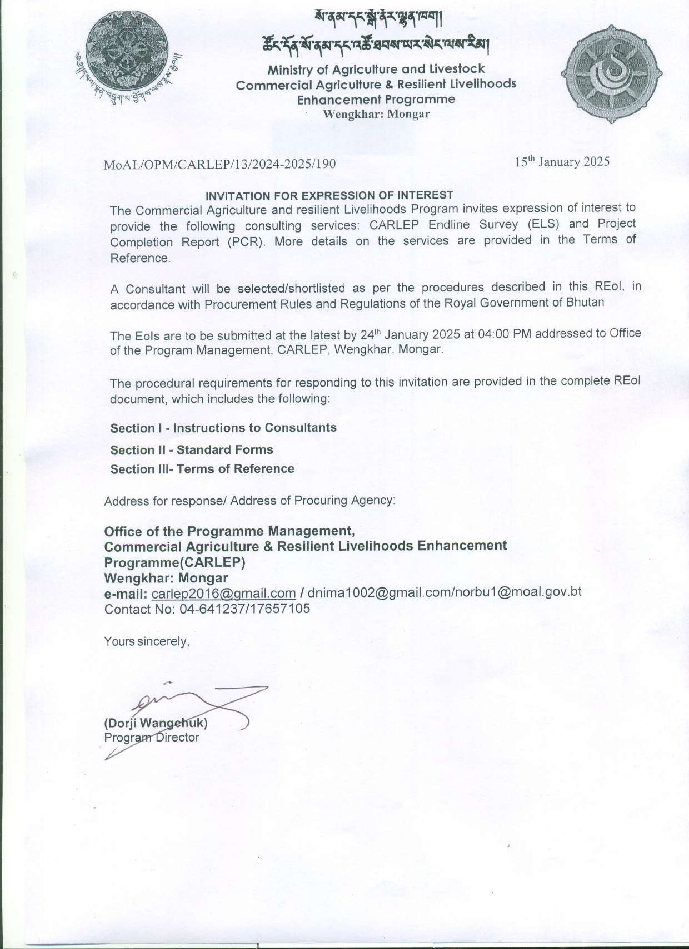

# SECTION I: INSTRUCTIONS TO CONSULTANT

1. Scope of Assignment: The Employer has received a budget from IFAD GRANTand intends to select a Consultant for the specific assignment as specified in the Terms of Reference in Section III.
2. Qualifications of the Consultant: Prospective Consultants shall demonstrate in their EoI that they meet the required qualifications and experiences and are fully capable of carrying out the assignment. The Consultancy firm will also submit CV of the lead experts required for the assignment.
3. Conflict of Interest**:** The Consultant shall hold the Procuring Agency’s interests paramount, without any consideration for future work, and strictly avoid conflict with other assignments or its own corporate interests. For this purpose, the provisions of the Procurement Rules and Regulations on Conflict of Interest shall apply.
4. Unfair Advantage: If a Consultant could derive a unfair competitive advantage from having provided Consulting Services related to the assignment in question, the Procuring Agency shall make available to all Consultants together with this REoI all information that would in that respect give such Consultant any unfair competitive advantage over competing Consultants.
5. Preparation of EoI: EoI shall be typed or written in indelible ink in English language and shall be signed by the Consultant. Consultants are required to complete the following Forms including supporting documents to substantiate the qualification and experience of the firm:

### Section I - Instructions to Consultants Section II - Standard Forms

### Section III- Terms of Reference

1. Submission of EoI : The prospective Consultant may deliver their EoI by hand, mail, courier service to the address mentioned in the REoI.
2. The EoI shall be properly sealed in envelopes addressed to the Procuring Agency as mentioned in the REoI advertisement and bear the name & address of the Consultant as well as the name of the assignment.
3. The closing date for submission of EoI is 24th January 2025 at 04:00 PM. Any EoI received after the deadline for submission of EoI shall be declared late, and returned unopened to the Consultant.
4. The EoI may be modified or substituted before the deadline for submission. The Procuring Agency may at its sole discretion, extend the deadline for submission of EoI.
5. At any time prior to the deadline for submission of EoI the Procuring Agency for any reason or on its own initiative may revise the REoI Document by issuing an addendum, which shall form an integral part of the Document.
6. Evaluation: The Consultants shall be evaluated on the following criteria:

*[The Procuring Agency may modify and allocate the following indicative points based on their requirements and further breakdown each criteria into sub- criteria and allocate points accordingly].*

|  |  |  |
| --- | --- | --- |
| **Sl. No** | **Criteria** | **Points** |
| 1 | General experience of the firm (Experience in development communication) | 10 |
| 2 | Relevant experience of the firm that best fit with proposed assignment | 30 |
| 3 | Technical competency of Firm’s professional staff (including external professionals to be hired for the proposed assignment) in reference to the proposed assignment | 40 |
| 4 | Proposed methodology and work plan | 10 |
| 5 | Availability of high-quality filming equipment | 10 |
| **7** | **Total** | **100** |

*[When the total points allocated is less than 100 the final points awarded should be scaled up/ converted out of 100 points*]

*Note: The Consultants/Consultancy Firm/Media Company must secure 75% and above for the purpose of short listing.*

1. Immediately after the closing date and time for submission, the Procuring Agency shall open all EoI documents, including any substitutions accompanied by a properly authorized substitution notice.
2. Following the opening of the EoI, and until the RFP is issued; no Consultant shall make any unsolicited communication to the Procuring Agency. Such an attempt to influence the Procuring Agency in its decisions on the examination, evaluation, and comparison of the EoI may result in the rejection of the EoI.
3. EoIs shall be evaluated based on the criteria outlined under clause 11. Request for Proposal (RFP) documents shall be issued to the shortlisted consultants only.

# SECTION II: STANDARD FORMS

Form 1: Sample letter of Expression of Interest Form 2: Firm Information Sheet

Form 3: General Experience of the Firm during the Last 5 (five) calendar Years Form 4: Relevant Experience of the Firm during the Last 5 (five) calendar Years Form 5: Relevant Experience of the Firm’s Professional Staff

Form 6: Relevant Experience of the External Professional Staff available to the Firm

## Form 1: Sample Expression of Interest (EOI) for Consultancy services

Date:

To

*[Insert address of Procuring Agency]*

Sub: **Expression of Interest (EOI) for the Consultancy Service …….***[Insert title of Consulting Services]*

Dear Sir/Madam,

This is in response to your public notice published in *[…………..insert name of paper/ website……………………]* on *[……insert date……………]*, inviting expression of interest for *[insert description of Consulting services].* We hereby submit our expression of interest and have attached necessary information according to the standard forms.

The information furnished by us in this expression of interest is correct to the best of our knowledge. Based on this information, we understand you would be able to evaluate our proposals in order to shortlist for the above-mentioned assignment. We, however, understand that the Procuring Agency reserves the right to decide whether or not to shortlist our firm without disclosing the reason whatsoever.

Sincerely yours,

On behalf of the firm: Signature: …………………. Name of signatory: Designation:

Company Seal

## Form 2: Firm Information Sheet

### Consulting Services Data

|  |  |
| --- | --- |
| Name of the consulting services |  |
| Brief Description of the Assignment |  |

### (a) Consulting Firm Information

|  |  |
| --- | --- |
| Name of the consulting firm: | Country of Registration: |
| Name of the owner: | Day, month & Year of Establishment: |
| Name of Authorized Representative (*if applicable*): | Position/Designation: |
| Contact Person details:  Name, Designation, email and phone number |  |

*[Attach valid Trade License /Registration certificate]*

### (b) Associations (Joint Venture or Sub-consultancy)

|  |  |  |  |  |
| --- | --- | --- | --- | --- |
| Name of the consulting firm | Country of Registration | Joint Venture (JV) or Sub- consultant | Name of Owner/ Authorized representative | Position/Designation |
|  |  |  |  |  |
|  |  |  |  |  |
|  |  |  |  |  |
|  |  |  |  |  |

*[Attach Certificate of Registration of the lead member, Certificate of Registration of the JV mem- ber (for each member) Certificate of Registration of the Sub-Consultant (for each sub-consultant), Letter of Association/letter of Intent to form JV/Association]*

* 1. **Core Area of expertise of the firm** *[Provide a brief Description]*
  2. **Company Profile** *[Provide a brief Description]*
  3. **Available Equipment** *[where applicable]*

Provide list of equipment owned by the firm and relevant for the assignment

## Form 3: General Experience of the Firm during the Last 5 (five) Calendar Years

9

|  |  |  |  |  |  |  |  |  |
| --- | --- | --- | --- | --- | --- | --- | --- | --- |
| **Sl. No** | **Name of the assignment** | **Name of the client** | **Address of the client** | **Duration of the assignment** | | | **Total Cost of the assignment Nu.** | **Remarks** |
| **From (Date)** | **To (Date)** | **Total (Months)** |
|  |  |  |  |  |  |  |  |  |
|  |  |  |  |  |  |  |  |  |
|  |  |  |  |  |  |  |  |  |
|  |  |  |  |  |  |  |  |  |
|  |  |  |  |  |  |  |  |  |
|  |  |  |  |  |  |  |  |  |
|  |  |  |  |  |  |  |  |  |

## Form 4: Relevant Experience of the Firm during the Last 5 calendar Years

10

|  |  |  |  |  |  |  |  |  |
| --- | --- | --- | --- | --- | --- | --- | --- | --- |
| **Sl. No** | **Name of the assignment** | **Name of the client** | **Address of the client** | **Duration of the assignment** | | | **Total Cost of the assignment Nu.** | **Remarks** |
| **From (Date)** | **To (Date)** | **Total (Months)** |
|  |  |  |  |  |  |  |  |  |
|  |  |  |  |  |  |  |  |  |
|  |  |  |  |  |  |  |  |  |
|  |  |  |  |  |  |  |  |  |
|  |  |  |  |  |  |  |  |  |
|  |  |  |  |  |  |  |  |  |
|  |  |  |  |  |  |  |  |  |

## Form 5: Relevant Experience of the Firm’s Professional Staff

11

|  |  |  |  |  |  |  |  |  |  |
| --- | --- | --- | --- | --- | --- | --- | --- | --- | --- |
| **Sl. No** | **Name of the Staff** | **Qualification** | **Total Years of**  **experience** | **Relevant experience** | | | | | |
| **Name of assignment** | **Client** | **Position** | **Duration** | | |
| **From (Date)** | **To (Date)** | **Duration (Months)** |
|  |  |  |  |  |  |  |  |  |  |
|  |  |  |  |  |  |  |  |  |  |
|  |  |  |  |  |  |  |  |  |  |
|  |  |  |  |  |  |  |  |  |  |
|  |  |  |  |  |  |  |  |  |  |
|  |  |  |  |  |  |  |  |  |  |

## Form 6: Relevant Experience of the External Professional Staff available to the Firm

12

|  |  |  |  |  |  |  |  |  |  |
| --- | --- | --- | --- | --- | --- | --- | --- | --- | --- |
| **Sl. No** | **Name of the Staff** | **Qualification** | **Total Years of**  **experience** | **Relevant experience** | | | | | |
| **Name of assignment** | **Client** | **Position** | **Duration** | | |
| **From (Date)** | **To (Date)** | **Duration (Months)** |
|  |  |  |  |  |  |  |  |  |  |
|  |  |  |  |  |  |  |  |  |  |
|  |  |  |  |  |  |  |  |  |  |
|  |  |  |  |  |  |  |  |  |  |
|  |  |  |  |  |  |  |  |  |  |
|  |  |  |  |  |  |  |  |  |  |

**Terms of Reference for the Production of Video Documentary on CARLEP Projects Best Practices, Successes and Lessons Learnt**

# Background

This document provides Terms of Reference (ToR) for producing video documentary highlighting some of the theme-based significant achievements from the decade long CARLEP interventions in the Eastern part of Bhutan covering Lhuentse, Mongar, Pemagatshel, Samdrup Jongkhar, Trashigang and Trashiyangtse.

Commercial Agriculture and Resilient Livelihoods Enhancement Programme (CARLEP), being funded by the International Fund for Agriculture development (IFAD), is implemented by the Ministry of Agriculture and Livestock (MoAL) with Office of the Programme Management set up at ARDC, Wengkhar, Mongar. The project was initially designed for seven years from 2016 until 2022 but with the approval of additional financing the project has been extended by three years and will be completed in end of 2025, making it a 10-year project. CARLEP's core objective is to transform Bhutan's subsistence-based rural agricultural economy into a sustainable, market-driven sector through climate-smart agricultural approaches, private sector engagement in agricultural commercialization, and strengthened community and local institutional capacities. The goal and objective is to sustainably increase smallholder farmers’ incomes and reduce rural poverty. This will be achieved through climate resilient commercialized production of crops and livestock by programme households linked to nationally organized value chains and marketing systems. The Programme initially targeted selected gewogs in six eastern Dzongkhags with high production and marketing potential in the selected value chains expected to benefit 28,975 smallholder households, of which 7115 households will directly benefit from vegetable and dairy value chains. However, the coverage was not only confined to the selected gewogs but went beyond it, and in fact almost all the gewogs in eastern Bhutan were literally covered by the project.

The Programme consists of four key components[1]: i) market-led sustainable agricultural production with three main outputs such as increased production resilience, diversification and innovation; intensification and expansion of vegetable production (amended as intensification, expansion and establishment of nutritious high value commodities after approval of additional financing); and intensification and expansion of dairy production; ii) Value chain development and marketing with three main outputs such as resilient vegetable and dairy value chains developed; agriculture commercialization and enterprise development strengthened; and development of community-driven market infrastructures; iii) Institutional support and policy development; and iv) Programme management.

# Objectives of the Assignment

The overall objective of the assignment is to produce a documentary video with a theme- “A decade of CARLEP journey in eastern Bhutan: Approaches and Best Practices” and production of four 3-5 minutes long video (as given in scope of work) with focus on capturing our key results, successes and challenges, best practices and lessons learnt from the project

# Scope of work

The Consultant/Media Company will be responsible for developing concepts, writing scripts and creating storyboards and providing full-fledged videography support to produce a set of high-quality videos (3-5 minutes long video clips) on the following key thematic areas capturing key results, success and challenges, best practices and lessons learnt:

* A success story of a climate smart village: A case of Ngarpentang CSV in Thangrong gewog
* A dairy value chain model: Towards achieving white revolution
* Aggregators’ role in marketing RNR products (Focusing on Eastern Region Marketing Cooperative (EAMC))
* Transforming mushroom enterprise with IoT based automation

In addition, the Consulting firm/media company will also be responsible for producing an overall project video documentation of 10-15 minutes long with a theme- A Decade of CARLEP-IFAD Journey in Eastern Bhutan: Approaches and Practices.

# Methodology

* Desk review of the project documents and trying to conceptualize the project interventions and then providing conceptual framework, script writing and drawing field visit plans. The Consultant may take the opportunity to visit Office of the Programme Management to discuss and improve the scripts and narratives.
* Conduct on-site filming according to the finalized script and schedule and ensure collecting relevant footages including important events, best practices, significant impacts. The Consultant will be required to travel to multiple locations to perform appropriate video filming and shoot interviews with the projects’ beneficiaries and stakeholders. The Consultant shall ensure high-quality footage with proper lighting, audio and camerawork through the use of professional-grade equipment.
* Carry out editing of the raw footage to create a cohesive narrative as per the approved script. Incorporate background music, necessary transitions, voiceovers, subtitles, graphics, remove wind and external noise and do colour correction and matching where necessary.
* Based on the finalized script and story, deliver the first draft to the OPM for review and feedbacks and then refine the contents accordingly before final submission to the procuring agency.
* Deliver the final videos compatible for maximum devices including phones, computer, projector, HD screen and other social media platforms and websites. Ensure that the final product is without errors, visually appealing and meets all quality standards. Language of video should be in English with Dzongkha sub-title.

# Deliverables

* Submit a storyboard and script for the documentary to the procuring agency for approval before filming.
* A separate four short videos (3-5 minutes long) as mentioned in the scope of work, with original background score, sub-title, and narration.
* High definition edited final 10-15 minutes long video on the theme- A Decade of CARLEP-IFAD Journey in Eastern Bhutan: Approaches and Practices, with original background score, sub-title, and narration.
* The above videos shall be submitted in English with Dzongkha sub-title.
* Raw footages, snippets, interviews, time lapses, photos, background scores, working files, etc. should be stored in separate folders along with the final videos in a hard drive during submission.

# Qualifications

The firm should have qualifications and experience as follows:

* More than three years of experience working in similar field
* Proven experience in video production, particularly in development-related documentaries.
* Excellent technical capacities (state-of the-art filming equipment preferably high definition) to ensure smooth and high-quality production
* Experience in development communication
* Experience working in rural settings and engaging with diverse stakeholders.

# Duration of the consultancy services and tentative timeline

The assignment is expected to take three months from the date of signing the contract.

|  |  |  |  |
| --- | --- | --- | --- |
| **Sl. No.** | **Deliverables** | **Timeline** | **Estimated No. of days** |
| 1 | Desk review of the project documents and development of conceptual framework including script writing and field visit time | 3rd Feb 2025 | 12 days |
| 2 | Submission of the storyboard and script to the PA for approval | 17th Feb 2025 | 3 days |
| 2 | Travel to the field (multiple locations) for video filming and shoot interviews with the project beneficiaries and stakeholders. | 20th Feb 2025 | 21 days |
| 3 | Editing of the video footages | 14th March 2025 | 20 days |
| 4 | Presentation of draft video documentaries and incorporation of feedbacks | 7th April 2025 | 7 days |
| 5 | Presentation of final edited version of the documentaries in appropriate format (Including raw footages, snippets, interviews, time lapses, photos, background scores, working files, etc. should be stored in separate folders along with the final videos in a hard drive during submission) | 14th April 2025 | 3 days |
|  | **Total estimated days** |  | **65 days** |

# Payment Terms

Payment shall be made in three instalments as follows:

* 30% of the contract amount after submission and acceptance of the storyboard and script
* 40% of the contract amount upon submission of draft documentaries
* 30 % of the contract amount after submission of final edited videos and acceptance by the PA

# ANNEXURE:

*[Attach any other documents from the Procuring Agency and the Consultants, if applicable]*

1. Please refer to [final project design report](https://www.carlep.gov.bt/wp-content/uploads/2016/11/Programme-Design-Report-PDR-1.pdf) for detailed review of components and outputs